**MICROBANKS: EXAMPLE OF INDIA**

**Anna Sosna, Agnieszka Szkutek**

# Microfinance

Microfinance is a source of financial services for entrepreneurs and small businesses lacking access to banking and related services. The two main mechanisms for the delivery of financial services to such clients are relationship-based banking for individual entrepreneurs and small businesses and group-based models, where several entrepreneurs come together to apply for loans and other services as a group.

For some people, microfinance is a movement whose object is a world in which as many poor households as possible have access to high quality financial services, including not just credit but also savings, insurance, and fund transfers. Many of those who promote microfinance believe that such access will help poor people out of poverty. For others, microfinance is a way to promote economic development, employment and growth through the support of micro-entrepreneurs and small businesses.

Microfinance is a broad category of services, which includes microcredit. Microcredit is provision of credit services to poor clients. Proponents often claim that microfinance lifts people out of poverty, but the evidence is mixed. It does however enhance financial inclusion.

## Background

In developing economies and particularly in rural areas, many activities that would be classified in the developed world as financial are not monetized: that is, money is not used to carry them out. This is often the case when people need the services money can provide but do not have dispensable funds required for those services, forcing them to revert to other means of acquiring them.

In their book The Poor and Their Money, Stuart Rutherford and Sukhwinder Arora cite several types of needs:

* *Lifecycle Needs*: such as weddings, funerals, childbirth, education, home building, widowhood and old age.
* *Personal Emergencies*: such as sickness, injury, unemployment, theft, harassment or death.
* *Disasters*: such as fires, floods, cyclones and man-made events like war or bulldozing of dwellings.
* *Investment Opportunities*: expanding a business, buying land or equipment, improving housing, securing a job, etc.

People find creative and often collaborative ways to meet these needs, primarily through creating and exchanging different forms of non-cash value. Common substitutes for cash vary from country to country but typically include livestock, grains, jewelry and precious metals. As Marguerite Robinson describes in The Micro finance Revolution, the 1980s demonstrated that "micro finance could provide large-scale outreach profitably," and in the 1990s, "micro finance began to develop as an industry" (2001, p. 54). In the 2000s, the micro finance industry's objective is to satisfy the unmet demand on a much larger scale, and to play a role in reducing poverty. While much progress has been made in developing a viable, commercial micro finance sector in the last few decades, several issues remain that need to be addressed before the industry will be able to satisfy massive worldwide demand. The obstacles or challenges to building a sound commercial micro finance industry include:

* Inappropriate donor subsidies
* Poor regulation and supervision of deposit-taking micro finance institutions (MFIs)
* Few MFIs that meet the needs for savings, remittances or insurance
* Limited management capacity in MFIs
* Institutional inefficiencies
* Need for more dissemination and adoption of rural, agricultural micro finance methodologies

Microfinance is the proper tool to reduce income inequality, allowing citizens from lower socio-economical classes to participate in the economy. Moreover, its involvement has shown to lead to a downward trend in income inequality (Hermes, 2014).

## Money management by poor people

Rutherford argues that the basic problem that poor people face as money managers is to gather a 'usefully large' amount of money. Building a new home may involve saving and protecting diverse building materials for years until enough are available to proceed with construction. Children’s schooling may be funded by buying chickens and raising them for sale as needed for expenses, uniforms, bribes, etc. Because all the value is accumulated before it is needed, this money management strategy is referred to as 'saving up'.

Often, people don't have enough money when they face a need, so they borrow. A poor family might borrow from relatives to buy land, from a moneylender to buy rice, or from a microfinance institution to buy a sewing machine. Since these loans must be repaid by saving after the cost is incurred, Rutherford calls this 'saving down'. Rutherford's point is that microcredit is addressing only half the problem, and arguably the less important half: poor people borrow to help them save and accumulate assets. Microcredit institutions should fund their loans through savings accounts that help poor people manage their myriad risks.

The work of Rutherford, Wright and others has caused practitioners to reconsider a key aspect of the microcredit paradigm: that poor people get out of poverty by borrowing, building microenterprises and increasing their income. The new paradigm places more attention on the efforts of poor people to reduce their many vulnerabilities by keeping more of what they earn and building up their assets. While they need loans, they may find it as useful to borrow for consumption as for microenterprise. A safe, flexible place to save money and withdraw it when needed is also essential for managing household and family risk.

## Example of “saving up” in India

The microfinance project of "saving up" is exemplified in the slums of the south-eastern city of Vijayawada, India. This microfinance project functions as an unofficial banking system where Jyothi, a "deposit collector", collects money from slum dwellers, mostly women, in order for them to accumulate savings. Jyothi does her rounds throughout the city, collecting Rs5 a day from people in the slums for 220 days, however not always 220 days in a row since these women do not always have the funds available to put them into savings. They ultimately end up with Rs1000 at the end of the process.

However, there are some issues with this microfinance saving program. One of the issues is that while saving, clients are actually losing part of their savings. Jyothi takes interest from each client—about 20 out of every 220 payments, or Rs100 out of 1,100 or 8%. When these slum dwellers find someone they trust, they are willing to pay up to 30% to someone to safely collect and keep their savings. There is also the risk of entrusting their savings to unlicensed, informal, peripatetic collectors. The slum dwellers are willing to accept this risk because they are unable to save at home, and unable to use the remote and unfriendly banks in their country. This microfinance project also has many benefits, such as empowering women and giving parents the ability to save money for their children’s education. This specific microfinance project is a great example of the benefits and limitations of the "saving up" project (Rutherford, 2009).

# Microfinance Standards and Principles

Poor people borrow from informal moneylenders and save with informal collectors. They receive loans and grants from charities. They buy insurance from state-owned companies. They receive funds transfers through formal or informal remittance networks. It is not easy to distinguish microfinance from similar activities. It could be claimed that a government that orders state banks to open deposit accounts for poor consumers, or a moneylender that engages in usury, or a charity that runs a heifer pool are engaged in microfinance. Ensuring financial services to poor people is best done by expanding the number of financial institutions available to them, as well as by strengthening the capacity of those institutions. In recent years there has also been increasing emphasis on expanding the diversity of institutions, since different institutions serve different needs.

Some principles that summarize a century and a half of development practice were encapsulated in 2004 by CGAP and endorsed by the Group of Eight leaders at the G8 Summit on June 10, 2004:

1. Poor people need not just loans but also savings, insurance and money transfer services.
2. Microfinance must be useful to poor households: helping them raise income, build up assets and/or cushion themselves against external shocks.
3. "Microfinance can pay for itself." Subsidies from donors and government are scarce and uncertain and so, to reach large numbers of poor people, microfinance must pay for itself.
4. Microfinance means building permanent local institutions.
5. Microfinance also means integrating the financial needs of poor people into a country's mainstream financial system.
6. "The job of government is to enable financial services, not to provide them."
7. "Donor funds should complement private capital, not compete with it."
8. "The key bottleneck is the shortage of strong institutions and managers." Donors should focus on capacity building.
9. Interest rate ceilings hurt poor people by preventing microfinance institutions from covering their costs, which chokes off the supply of credit.
10. Microfinance institutions should measure and disclose their performance—both financially and socially.

Microfinance is considered a tool for socio-economic development, and can be clearly distinguished from charity. Families who are destitute, or so poor they are unlikely to be able to generate the cash flow required to repay a loan, should be recipients of charity. Others are best served by financial institutions.

# Micro Finance in India

In the developing world, India presents a unique opportunity and need for poverty alleviation. India’s stable political environment and strong economic growth over the last years have put the country in a position to become the third-largest economy in the world by 2050. At the same time, India accounts for the largest share of the world’s poor with over 860million people in 2006 living on less than US$2 a day and economic development characterized by a widening income gap between the rich and poor parts of the country.

The vast numbers of poor people, combined with an increasingly favourable economic climate in India, presents a great opportunity to expand microfinance and alleviate poverty on a large scale.

## History of Micro Finance In India

The concept of microfinance is not new. Savings and credit groups that have operated for centuries include the "chit funds" in India. Chit fund concept came into the eyes of people in 1800's when Raja Rama Varma, ruler of erstwhile Cochin state gave a loan to a Syrian Christian trader, by keeping a certain portion of it to himself for other expenses. Later, to manage the increasing numbers of those seeking loans, he ordered a cast of lots and gave the accumulated amount to those who drew the lot on the principle of equity.

To improve financial access for India’s poor, 75% of whom are concentrated in rural areas, the Government create a nationwide network of rural cooperative banks in the 1950s. Gradually there was establishment of Regional Rural Banks (RRBs), Deposit Insurance and Credit Guarantee Corporation (DICGC), National Bank for Rural and Agricultural Development (NABARD) etc. This was followed by further measures aimed at increasing financial access - the nationalisation of commercial banks in the late 1960s, and an aggressive drive through the 1970s and 1980s to expand rural banking. It was following these reforms that the “Self-Help Groups (SHGs)–Bank Linkage” model grew to become a key part of finance for India’s poor. In recent years, other institutional structures for microfinance have emerged: notably, independent specialised microfinance institutions (MFIs). The success of MFIs in India has also attracted several new private sector banks, notably ICICI Bank, UTI Bank and HDFC Bank. Some of these newer banks are pursuing innovative approaches to microfinance. They view microfinance as a potential business rather than simply a social objective or priority sector lending obligation. The expansion of commercial banking has also led to a more favourable financial environment for the poor in India.

## MFI's

The Micro Finance Institutions (MFIs) accesses financial resources from the Banks and other mainstream Financial Institutions and provide financial and support services to the poor. Microfinance has a significant role in bridging the gap between the formal financial institutions and the rural poor. These institutions offer a range of financial services from small business loans to savings accounts, money transfers, insurance, and consumer loans.

The Indian Microfinance Sector has witnessed a phenomenal growth over the past 17 years. The number of Institutions providing microfinance services has gone up from a few to several hundreds. The quantum of credit made available to the poor and financially excluded clients has gone past 60,000 crore and number of clients benefited is close to 40 million as of March 2016. The Government of India and the Reserve Bank of India have created conducive policy and regulatory framework for Microfinance Institutions (MFIs) to operate in the country. This has provided necessary legitimacy and impetus to the sector. MFIs in general comply to the regulations, take care of client protection issues.

### Client Outreach

The total number of clients served by MFIs stood at 399 lakh (100000) as on 31 March, 2016. Client outreach of MFIs had grown substantially from 2005 to 2011. It is worth mentioning that Women clients constitute 97% of the total clients of MFIs.

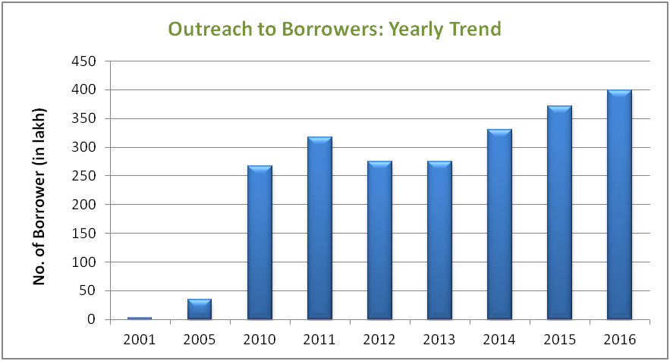

Though India has experienced strong economic growth at the national level in recent years, that growth has been uneven in its geographical distribution. This skewed distribution of growth is mirrored in the extent and availability of microfinance across regions. Out of the total client base of 399 lakh, Southern region alone contributes to 39% followed by 20% each in East and Central region whereas West and North have 13% and 6% of total outreach respectively. Northeast has the least client outreach numbers with 3%.

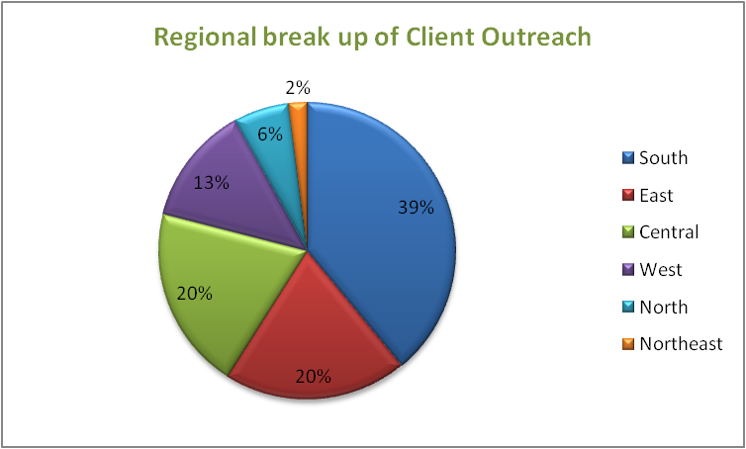

2014-15 can be described as watershed year as far as the rural-urban divide in Indian microfinance is concerned. As yet Indian microfinance was touted as basically a rural phenomenon, but that statement is no longer valid. A very interesting trend is seen in the rural-urban focus of MFIs. The share of rural clientele which was 69 % in 2012 decreased to 56 % in 2014 and has drastically come down to 33 %. The proportion of rural to urban clients for the year 2014-15 is 33% to 67%.

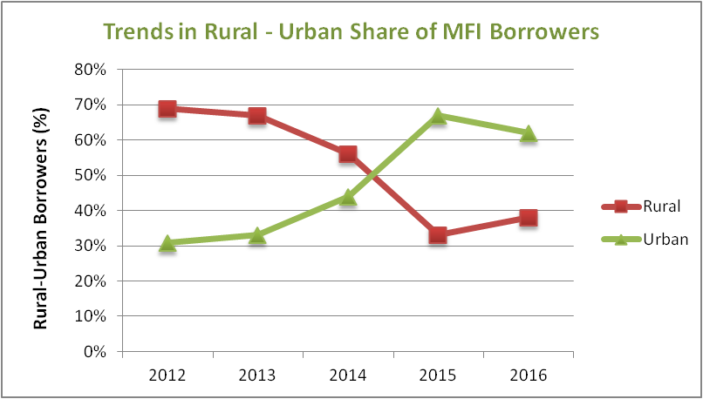

### Loan Portfolio

As of March 2016, the total loan portfolio of MFIs has reached an all time high of over 63,853 * 106 Ru which is a 31% growth over last year. Top ten MFI's contribute to 43887 * 106 Ru of loan portfolio which is 69% of the sector’s total.

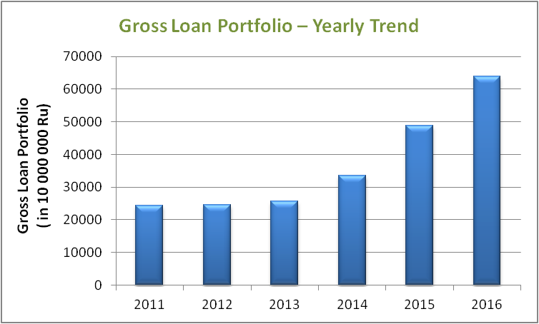

Among the regions, South also dominates the overall loan portfolio outstanding of MFIs with 40% followed by Central with 19%. East and West have a share of 18% and 14% respectively. While North and Northeast have least portfolio share of 7% and 2% respectively.

### Credit Plus Activity

There is a huge need for MFIs to expand their portfolio to credit plus products like microinsurance and micropensions. Some MFI's have already provide such a products. As per the self-reported data, 15 MFIs have reached to 3.66 lakh clients for health products, 39 MFIs have reached to 55.38 lakh clients for non-health products and 11 MFIs have been providing micropensions services to 18.59 lakhs clients.

## SGHs

A self-help group  is a village-based financial intermediary committee usually composed of 10–20 local women. A SHG may be registered or unregistered. It typically comprises a group of micro entrepreneurs having homogeneous social and economic backgrounds, all voluntarily coming together to save regular small sums of money. They pool money, and then use these funds to lend small amounts to each other with interest. Self-help groups are seen as instruments for goals including empowering women, developing leadership abilities among poor people, increasing school enrollments, and improving nutrition and the use of birth control. Financial intermediation is generally seen more as an entry point to these other goals, rather than as a primary objective.

### Self Help Group Bank Linkage Programme (SBLP)

Under 'SHG Bank Linkage' program established groups can apply for loans through their local bank branch, limited in size to a ratio of the group's own funds. This limit may be increased over time as previous loans are successfully repaid. This model has attracted attention as a possible way of delivering micro-finance services to poor populations that have been difficult to reach directly through banks or other institutions. By aggregating their individual savings into a single deposit, self-help groups minimize the bank's transaction costs and generate an attractive volume of deposits. There are also limitations in the way the model operates. SHGs are required to demonstrate an ability to save, learn bookkeeping skills and act as a cohesive group before they are permitted to borrow and because of this it can often take a year before groups are allowed to receive their first loans.

Trend of SHGs linked to banks has remained positive since the beginning though the credit linked SHGs have witnessed a decline during the year 2010-11 and 2011-12.

### Historical Trend in Credit Linkage and Bank Loan Disbursed

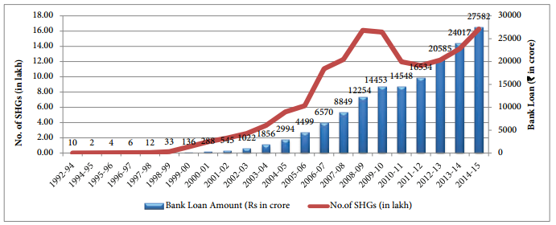

# Bibliografia

1. Microfinance, https://en.wikipedia.org/wiki/Microfinance
2. The Bharat Microfinance Report 2016,
3. "History of Micro Finance in India", Opportunity International Australia Limited, https://pl.scribd.com/document/43513428/History-of-Micro-Finance-in-India
4. https://en.wikipedia.org/wiki/Self-help_group_(finance)